Author Instructions for the Preparation of Contributions

Maria das Dores¹, José Ninguém²

¹ ITQB NOVA, Instituto de Tecnologia Química e Biológica António Xavier, Universidade Nova de Lisboa, Av. da República, 2780-157 Oeiras, Portugal
² Center for Innovation in Engineering and Industrial Technology, 4200-072, Porto, Portugal
mdores@itqb.unl.pt

The abstract should summarize the contents of your contribution and should contain at least 100 and at most 300 words not exceeding one A4 page. It should be inset 3.0 cm from the right and left margins. This document is in the required format. Figures are optional but encouraged.
For the title, please use 14-point type font Times New Roman with left alignment. Use bold, 12-point Times New Roman for the name(s) of the author(s), use normal, 12-point Times New Roman for the address(es), and use 12-point Times New Roman for the email(s). For the main text, please use 11-point Times New Roman, single-line spacing and 6 pt spacing after the paragraph, and use 11-point type for the reference list. Bold formatting may be used to emphasize words in running text. For citations in the text please use square brackets and consecutive numbers: [1], for URL [2].
The authors should submit their files in .docx through the online registration form with the filename including the corresponding author`s name and surname in the format: EURCON2026_Maria_das_Dores.docx. We would like to draw your attention to the fact that it is not possible to modify an abstract in any way, once it has been submitted. Every detail, including the order of the names of the authors, should be checked before the abstract is submitted. This text is approximately 300 words long.
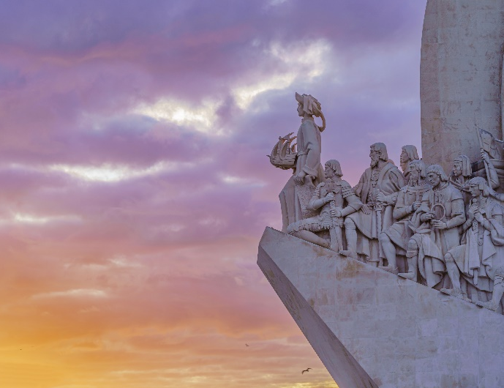
Figure 1: A descriptive title. Figures are optional but encouraged. The figure description does not count towards the abstract word limit. The entire abstract with figure and references must not exceed a single page. The caption can be moved below the figure if necessary.

References:
- Soares, C.M. and Lousa, D. (2025), Structural Bioinformatics: exciting times in a rapidly evolving field. FEBS Open Bio, 15: 200-201. https://doi.org/10.1002/2211-5463.13968
- EU Rosetta Con 2026. https://europeanrosettacon.org/, 2026-03-01

